**“Prakruti Parikshan”**

*Date of Event: December 2024*

On **December 2024**, **SBMN Ayurvedic College, Rohtak.**, successfully organized a **Prakruti Parikshan Campaign.** The campaign aimed to analyse and enhance the health awareness of students and faculty by providing detailed Prakruti (body constitution) assessments.

**Key Features of the Program**

1. **Collaboration and Medical Support**:

The campaign was conducted with the active involvement of doctors from **SBMN Ayurvedic College and Hospital**, who brought their expertise to assess the Prakruti of

participants.

2. **Health Awareness Drive**:

o This initiative aimed to provide personalized health insights and recommendations,

enabling participants to adopt healthier lifestyles tailored to their body constitution.

**Institutional and Collaborative Efforts**

• The program was organized under the leadership of **Principal Dr. Ajay Dahiya**, who

provided all necessary facilities and support to ensure the event's success.

• **NSS Unit** of the college, led by Program Officers **Dr. Nitin Jain,** **Dr. Nisha**

, and all faculty members actively participated in organizing and managing

the event.

• The event highlighted the collaborative efforts of the college’s departments in promoting

health awareness.

**Participation and Outcomes**

• The campaign attracted enthusiastic participation from both students and staff, reflecting

the college's commitment to health and well-being.

• Participants received personalized **Digital Prakruti Certificates**, detailing their Prakruti

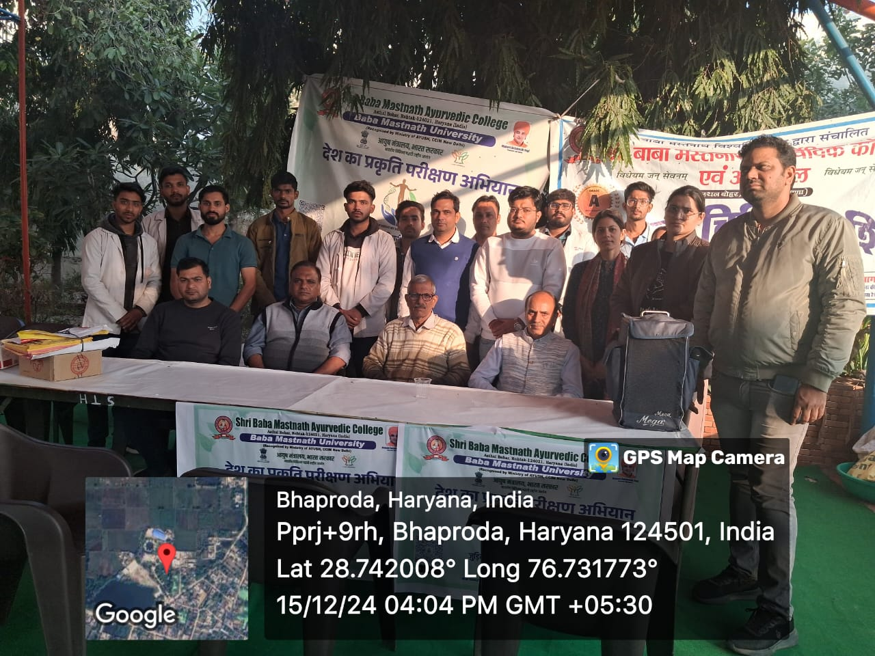analysis and providing health guidelines tailored to their individual constitutions.

